**Foodbox**

1. **Foodbox**

**This document contains sections for:**

* Project Description
* Core concepts used in project
* Flow of the Application.
* Project Users Stories : ( Agile and Scrum )
* Git Repositories
* How to run project
* Outputs
* Unique Selling Points of the Application
* Conclusions

The project is developed by Akhila Vemulapalli

**Features of the application:**

1. Registration
2. Login
3. Payment gateway
4. Searching
5. Filtering
6. Sorting
7. Dynamic data
8. Responsive and compatible with different devices

**Recommended technologies:**

1. Database management: MySQL and Oracle
2. Backend logic: Java programming, NodeJS
3. Frontend development: JSP, Angular, Bootstrap, HTML/CSS, and Javascript
4. Automation and testing technologies: Selenium, Jasmine, and TestNG
5. DevOps and production technologies: Git, GitHub, Jenkins, Docker, Kubernetes, and AWS

**Project development guidelines:**

* The project will be delivered within four sprints with every sprint delivering a minimal viable product.
* It is mandatory to perform proper sprint planning with user stories to develop all the components of the project.
* The learner can use any technology from the above-mentioned technologies for different layers of the project.
* The web application should be responsive and should fetch or send data dynamically without hardcoded values.
* The learner must maintain the version of the application over GitHub and every new change should be sent to the repository.
* The learner must implement a CI/CD pipeline using Jenkins.
* The learner should also deploy and host the application on an AWS EC2 instance.
* The learner should also implement automation testing before the application enters the CI/CD pipeline.
* The learner should use Git branching to do basic automation testing of the application in it separately.
* The learner should make a rich frontend of the application, which is user- friendly and easy for the user to navigate through the application.
* There will be two portals in the application, namely admin and user portal.

**Admin Portal:**  
The admin portal deals with all the backend data generation and product information. The admin user should be able to:

* Add or remove different cuisines to or from the application to build a rich product line
* Edit food item details like name, price, cuisine, description, and offers to keep it aligned to the current prices
* Enable or disable the food items

**User Portal:**  
It deals with the user activities. The end-user should be able to:

* Sign-in to the application to maintain a record of activities
* Search for food items based on the search keyword
* Apply filters and sort results based on different cuisines to get the best deals
* Add all the selected food items to a cart and customize the purchase at the end
* Perform a seamless payment process
* Get an order summary details page once the payment is complete
  1. **Core concepts used in the project:**
  2. **Front End:**

HTML.

CSS3 and Bootstrap4. TypeScript.

Angular, Angular Material for View.

* 1. **VS Code:** As an IDE to design frontend of the application.
  2. **Git:** To connect and push files from the local system to GitHub.
  3. **GitHub:** To store the application code and track its versions
  4. **Scrum:** An efficient agile framework to deliver the product incrementally.
  5. **Back End:**

Eclipse IDE.

Java Programming.

Searching and Sorting Spring Boot DevTools.

Spring Web and Spring Data JPA.

* 1. **Testing and DevOps:**

Selenium. Jenkins.

Docker and TestNG..

1. **Architecture diagram / flow chart**

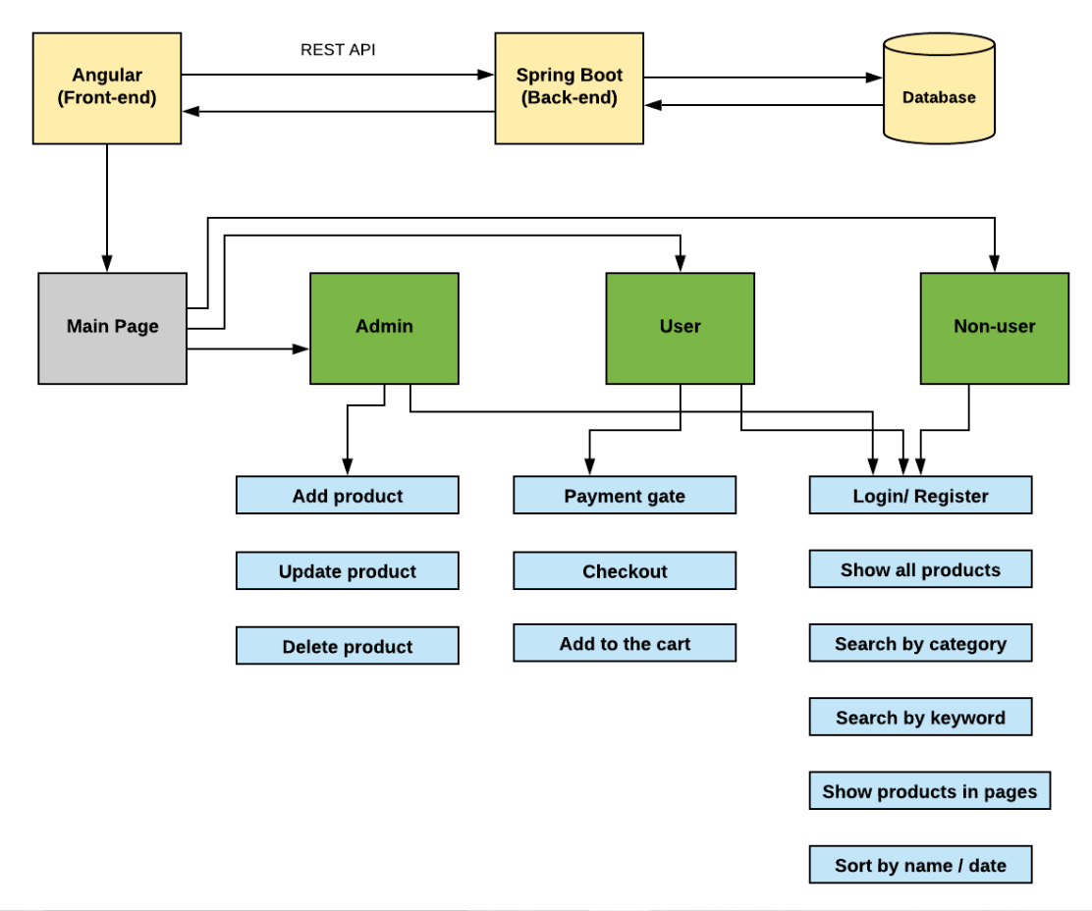

## **Unique Selling Points of the Application**

1. The application is designed to keep on running and taking user inputs even after exceptions occur. To terminate the application, appropriate option needs to be selected.
2. With this application, one can easily access the food items as their own by adding cart.
3. Total price is also determined by its own.
4. Any user can signed up and no restrictions.
5. Online payment is also accepted.

## **Conclusions**

At the end of the project we had acquired some of the materials and parts, some bought and some from the food. Very easy to use the application and easy to make payment.